快樂農舍
指導老師：趙文鴻
組員：林睦軒、簡正穎、羅兆倫、詹詠翔、謝祥遠
建國科技大學 創意產品與遊戲設計系
一、簡介：
名為快樂農舍，敘述一位玩家扮演的熱血青年，離開了農場
而經過城市的洗禮，直到有一天回想起兒時與爺爺在農場的回憶，
他毅然決然的辭下在城市的一切，回到了鄉村展開一場農村生活。
二、動機：
我們想藉由快樂農舍讓年輕一輩與上班族玩到樸實、和諧的鄉村農舍體驗，也讓現今社會上物質充裕的年輕人、小朋友們得以體驗、嘗試。
三、功能：
模擬養成類RPG遊戲，能體驗到傳統農業辛勞的過程與結果，以及與大自然親密接觸體驗的充實生活。除了種植農作物外還有著各式特色的腳色以及各種可愛的動物，提供玩家去收集與養成。
四、特色：
遊戲中的畫面使用Q版畫風呈現動物與植物，也加入了特殊動植物增加趣味，並且有著豐富色彩的農村背景圖讓玩家進行遊戲時除了能享受畫面美感也能體驗趣味。
五、原理：
使用Unity 2D 作為遊戲引擎
使用Adobe Photoshop及Adobe Illustrator進行美術繪畫
使用Adobe Photoshop進行動態美術調整
六、設備：
以手機APP遊戲方式呈現，主要是運作在安卓系統的手機遊戲。
七、運用時機：
手機版本：無需網路，下載後即可在手機中隨時隨地進行遊戲。
八、指導老師評語：
美術方面非常好
程式方面的需多努力加強。

九、專題（或作品）結構圖、或照片（1-2張）：

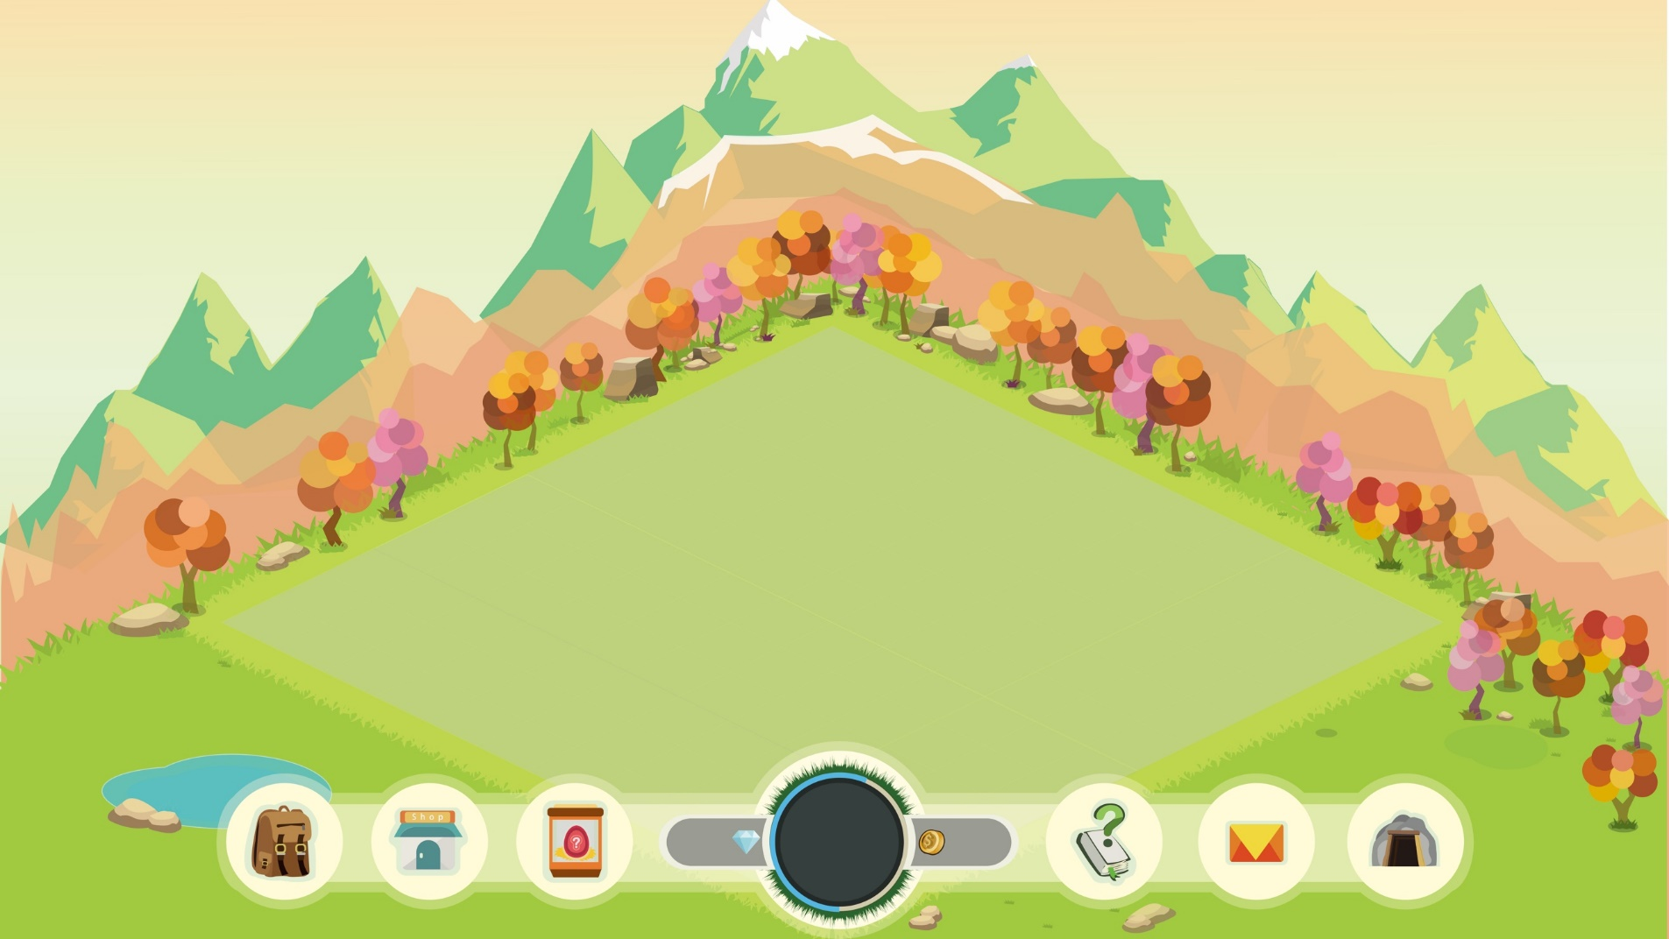
Happy Farmhouse
Advisor: ZHAO WEN HONG
Members: LIN MU XUAN、JIAN ZHENG YING、LUO ZHAO LUN
、ZHAN YONG XIANG、XIE XIANG YUAN
Department of Creative Products and Game Design , Chienkuo Technology University
1. Introduction:
Called happy farmhouse, describes a player to play the blood of youth, left the farm and baptized through the city until one day recalled childhood memories of grandfather in the farm, he resolutely resigned in the city everything, back to the Rural areas to start a rural life.
2. Motivation:
We want to let the younger generation and the office workers enjoy the simple and harmonious rural farmhouse experience by happy farmhouses, and let young people and children who are abundant in the society can experience and try.
3. Purpose:
Simulate the development of RPG games, to experience the hardships of traditional agricultural process and results, and intimate contact with nature to enrich the experience of life. In addition to planting crops, but also has a variety of characteristics of the role and a variety of cute animals, providing players to collect and develop.
4. Characteristic:
The picture in the game uses the Q version of the painting style of animals and plants, also joined the special animals and plants to increase the fun, and has a rich rural background color map allows players to play the game in addition to enjoy the beauty of the screen can also experience the fun.
5. Principle:
Use Unity 2D as the game engine
Use Adobe Photoshop and Adobe Illustrator for painting art
Use Adobe Photoshop for dynamic art adjustments
6. Methods:
To mobile phone APP game presentation, mainly operating in the Andrews system of mobile games.
7. Conclusion:
Phone version: no network, you can download the phone anytime, anywhere in the game.
8. Advisor’s Comments:
Art is very good
The program needs to be more efforts to strengthen.

9. Picture:

